Annual Quality Assurance Report (AQAR)
(Revised in October 2013)

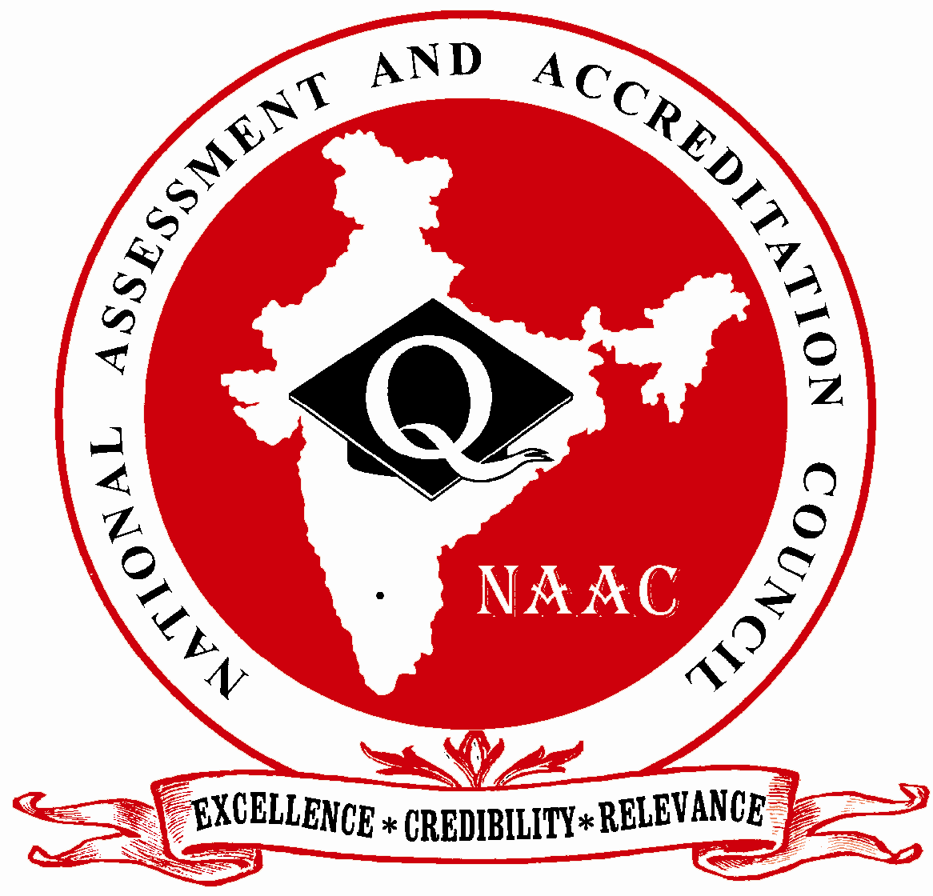

NATIONAL ASSESSMENT AND ACCREDITATION COUNCIL
An Autonomous Institution of the University Grants Commission
P. O. Box. No. 1075, Opp: NLSIU, Nagarbhavi, Bangalore - 560 072 India

Note:
The NAAC Accredited institutions need to submit only the soft copy as word file (.doc/.docx) through e-mail (naac.aqar@gmail.com). The file name needs to be submitted with Track ID of the institution and College Name. For example MHCOGN16601-Samudra Arts and Science College, Taliamegu-Maharashtra.doc or EC_32_A&A_143 dated 3-5-2004-Samudra Arts and Science College, Taliamegu-Maharashtra.doc. The Higher Education Institutions need not submit the printed/hard copy to NAAC. The acknowledgements would be sent to the institutions through e-mail.

The Annual Quality Assurance Report (AQAR) of the IQAC

All NAAC accredited institutions will submit an annual self-reviewed progress report to NAAC, through its IQAC. The report is to detail the tangible results achieved in key areas, specifically identified by the institutional IQAC at the beginning of the academic year. The AQAR will detail the results of the perspective plan worked out by the IQAC. (Note: The AQAR period would be the Academic Year. For example, July 1, 2012 to June 30, 2013)

Part – A
2014-15
AQAR for the year (for example 2013-14)

1. Details of the Institution
Rajdhani College
1.1 Name of the Institution
Baramunda
1.2 Address Line 1
Bhubaneswar
Address Line 2
Bhubaneswar
City/Town
odisha
State
751003
Pin Code
rajdhanicollege@yahoo.in
Institution e-mail address
06742562491
Contact Nos.
Dr Jahan Ara Begum
Name of the Head of the Institution:
06742562491
Tel. No. with STD Code:
09437095663
Mobile:
Dr Pranab Mangaraj
Name of the IQAC Co-ordinator:
09777918800
Mobile:
iqacrajdhani@gmail.com, drpmangaraj1961@gmail.com

IQAC e-mail address:

ORCOGN12763
1.3 NAAC Track ID (For ex. MHCOGN 18879)
OR

1.4 NAAC Executive Committee No. & Date:
EC/39/64
(For Example EC/32/A&A/143 dated 3-5-2004.
This EC no. is available in the right corner- bottom
of your institution’s Accreditation Certificate)

www.rajdhanicollege.org.in
1.5 Website address:
www.rajdhanicollege.org.in/AQAR 2014-15.doc

Web-link of the AQAR:
For ex. http://www.ladykeanecollege.edu.in/AQAR2012-13.doc

1.6 Accreditation Detail
Sl. No. | Cycle | Grade | CGPA | Year of Accreditation | Validity Period
1 | 1st Cycle | B+ | 75.30 | 2006 | 5 yrs W.E.F 21.05.06
2 | 2nd Cycle | LOI has been submitted on line on 24.09.14
3 | 3rd Cycle
4 | 4th Cycle

1.7 Date of Establishment of IQAC: DD/MM/YYYY
02.04.2014

1.8 Details of the previous year’s AQAR submitted to NAAC after the latest Assessment and Accreditation by NAAC ((for example AQAR 2010-11submitted to NAAC on 12-10-2011)
- AQAR : 2013-14 submitted on 23.6.14 (Hard copy)
- AQAR : 2014-15 submitted to NAAC on 02.07.2015
- AQAR__________________ _______________________ (DD/MM/YYYY)
- AQAR__________________ _______________________ (DD/MM/YYYY)
1.9 Institutional Status

University State Central Deemed Private
√

Affiliated College Yes No
Constituent College Yes No

Autonomous college of UGC Yes No

Regulatory Agency approved Institution Yes No
(eg. AICTE, BCI, MCI, PCI, NCI)
√

Type of Institution Co-education Men Women

Urban Rural Tribal

√

√

Financial Status Grant-in-aid UGC 2(f) UGC 12B

Grant-in-aid + Self Financing Totally Self-financing

1.10 Type of Faculty/Programme
√

Arts Science Commerce Law PEI (Phys Edu)
√

√

TEI (Edu) Engineering Health Science Management

Others (Specify)

1.11 Name of the Affiliating University (for the Colleges)
Utkal University, Bhubaneswar

1.12 Special status conferred by Central/ State Government-- UGC/CSIR/DST/DBT/ICMR etc : N.A

Autonomy by State/Central Govt. / University

University with Potential for Excellence UGC-CPE

DST Star Scheme UGC-CE

UGC-Special Assistance Programme DST-FIST

UGC-Innovative PG programmes Any other (Specify)

UGC-COP Programmes
2. IQAC Composition and Activities
07
2.1 No. of Teachers
02
2.2 No. of Administrative/Technical staff
2.3 No. of students
NIL
2.4 No. of Management representatives
01
01
2.5 No. of Alumni
2. 6 No. of any other stakeholder and
NIL
community representatives
NIL
2.7 No. of Employers/ Industrialists
01
2.8 No. of other External Experts
2.9 Total No. of members
10
2.10 No. of IQAC meetings held 08

05
2.11 No. of meetings with various stakeholders: No. Faculty

Non-Teaching Staff Students Alumni Others
√

2.12 Has IQAC received any funding from UGC during the year? Yes No
Rs 3, 00,000
If yes, mention the amount
2.13 Seminars and Conferences (only quality related)
(i) No. of Seminars/Conferences/ Workshops/Symposia organized by the IQAC
01

01
Total Nos. International National State Institution Level
“Violence against women in the age of Information Revolution”
(ii) Themes
2.14 Significant Activities and contributions made by IQAC
- Undertook Permanent University affiliation of all newly added Streams/Subjects and of seats added in various subjects and successfully accomplished it.
- Obtained the Track ID for the College.
- Academic audit made stricter
- Recruitment of one Technical Assistant from UGC funds
- Preparation of Annual Academic calendar
- Formation of Planning Board
- Publication of Annual Seminar Bulletin by Departments has been made mandatory.
- Provision of Degree Laboratories for the recently opened science subjects; Physics and Chemistry
- Subscription of professional journals in most of the subjects by the college library from the session 2014-15

2.15 Plan of Action by IQAC/Outcome
The plan of action chalked out by the IQAC in the beginning of the year towards quality
enhancement and the outcome achieved by the end of the year *

Plan of Action | Achievements
- Introduction of Annual Academic Calendar.  - Formation of the Governing Body  - Setting up of the Planning Board  - Compliance of Queries from the University/Govt./Public through RTI by the concerned sections/cells  - Infrastructure Development especially setting up Laboratories for +3Science students  - Campus Development  - 7.Recruitment of a Technical hand from UGC Funds  - 8.Creation of IT Zone in the library  - 9.Availability of reading Room Facility on all working days  - 10.Subscription of Professional journals in all subjects to promote the research climate  - 11.Xeroxing (of reading materials) facility for all library users  - ICT Training of Ministerial Staff of the College by Existing Faculty of the College 13.Provision of Question Banks for students  - 14.Planning of Seminar Activities by Heads of Departments at the beginning of the academic year  - 15.Publication of Annual Seminar Bulletins by all departments before the close of a n academic session  - 16.Activation of the defunct Alumni Association and publication of a Directory of College Alumn  - i 17.Creation of an Achievers’ Gallery to accord recognition to students who achieve excellence in curricular and co curricular fields. | - . Following IQAC recommendation, a Technical Assistant has been recruited to attend to the huge increase in the volume of administrative and academic work in the past couple of years.  - Library has subscribed to professional journals in most of the subjects from 14-15, as per the decision of the IQAC.  - Reading Room Facility is now available throughout the year except on holidays/vacations.  - Subscription of professional journals in major subjects has already started from 2014-15.  - Some Departments have provided Question Banks to their students.  - All the Proctors meet their respective groups from time to time to monitor the progress of students and redress their problems as far as practicable.  - Heads of Departments submit a tentative Seminar Schedule for the academic year ahead at the beginning of the session try to implement that to the maximum extent.  - Planning Board has been set up for deciding upon policy initiatives..  - Physics and Chemistry Lab have been set up with the help of Block Grant from UGC (1st Instalment) as per IQAC recommendation.  - Academic audit made stricter  - Preparation of Annual Academic calendar at the beginning of the session.  - Reconstitution of the Governing Body
* Attach the Academic Calendar of the year as Annexure.

2.15 Whether the AQAR was placed in statutory body Yes No

Management Syndicate Any other body
Provide the details of the action taken
IQAC pursued the matter of reconstituting the Governing Body, which was defunct since long with the authorities zealously and finally succeeded in getting the Government’s Order in this regard on 17.04.15. As of date, the Governing Body has not been convened because of various pressures; most important being that of the admission process .However, the authorities have plans to convene it in the month of July,2015.

Part – B
Criterion – I

1. Curricular Aspects

1.1 Details about Academic Programmes
Level of the Programme | Number of existing Programmes | Number of programmes added during the year | Number of self-financing programmes | Number of value added / Career Oriented programmes
PhD | NIL | 01(PG in Odia) | 01 (PG in Edn)
PG | 02
UG | 17
PG Diploma | NIL |  |  | 01 (PGDCA)
Advanced Diploma | NIL
Diploma | NIL
Certificate | NIL
Others | NIL
Total | 20

Interdisciplinary | NIL
Innovative | NIL

1.2 (i) Flexibility of the Curriculum: CBCS/Core/Elective option / Open options
(ii) Pattern of programmes:
Pattern | Number of programmes
Semester | 02
Trimester | -
Annual | 17

1.3 Feedback from stakeholders* Alumni Parents Employers Students
(On all aspects)

Mode of feedback : Online Manual Co-operating schools (for PEI)
*Please provide an analysis of the feedback in the Annexure

1.4 Whether there is any revision/update of regulation or syllabi, if yes, mention their salient aspects.
No Revision

1.5 Any new Department/Centre introduced during the year. If yes, give details.
PG course In Odia was introduced during 2014-15.

Criterion – II
2. Teaching, Learning and Evaluation
2.1 Total No. of permanent faculty
Total | Asst. Professors | Associate Professors | Professors | Others
38 | 11 | 27 | NIL | NIL
25
2.2 No. of permanent faculty with Ph.D.
2.3 No. of Faculty Positions Recruited (R) and Vacant (V) during the year : N.A
Asst. Professors |  | Associate Professors |  | Professors |  | Others |  | Total
R | V | R | V | R | V | R | V | R | V
20

2.4 No. of Guest and Visiting faculty and Temporary faculty

2.5 Faculty participation in conferences and symposia:

No. of Faculty | International level | National level | State level
Attended Seminars/ Workshops |  | 05 | 02
Presented papers |  | 03 | nil
Resource Persons |  | - | -

2.6 Innovative processes adopted by the institution in Teaching and Learning:
PowerPoint Presentations, Smart class with audio-visual aids , Proctorial System, Group Discussions and Weekly Seminars are some of the measures adopted by the institution for effective teaching and learning.

180
2.7 Total No. of actual teaching days
during this academic year
2.8 Examination/ Evaluation Reforms initiated by
Traditional Patterns except in PG Courses
the Institution (for example: Open Book Examination, Bar Coding,
Double Valuation, Photocopy, Online Multiple Choice Questions)
05
-
-
2.9 No. of faculty members involved in curriculum
restructuring/revision/syllabus development
as member of Board of Study/Faculty/Curriculum Development workshop
85% and above
2.10 Average percentage of attendance of students

2.11 Course/Programme wise
Distribution of pass percentage:

Title of the Programme | Total no. of students appeared | Division
Title of the Programme | Total no. of students appeared | Distinction % | I % | II % | III % | Pass %
+3 Arts Hons | 226 |  | 49% |  |  | 91%
+3 Science Hons
+3Commerce Hons

2.12How does IQAC Contribute/Monitor/Evaluate the Teaching & Learning processes :
In order to facilitate exposure o f students, it has recommended the inclusion of Guest Lectures by eminent subject experts in each department’s seminar schedule. It also recommended the publication of Annual Seminar Bulletin by all departments. The cell actively cooperates Career Guidance and Placement Cell in the organization of career related workshops by established professional agencies thereby creating linkages beneficial for the students. Power Point Presentations by teachers in class rooms and during seminars are encouraged. It has also recommended to the authority to allow departments to undertake field trips and academic outreach programmes on a larger scale.

2.13 Initiatives undertaken towards faculty development
Faculty / Staff Development Programmes | Number of faculty  benefitted
Refresher courses | 04
UGC – Faculty Improvement Programme | 08
HRD programmes | 05
Orientation programmes | -
Faculty exchange programme | -
Staff training conducted by the university | NIL
Staff training conducted by other institutions | 02  - PAR training at Madhusudan Academy BBSR  - Training on PL withdrawal (E-system) organized by finance dept Govt of Odisha
Summer / Winter schools, Workshops, etc. | NIL
Others | NIL
2.14 Details of Administrative and Technical staff
Category | Number of Permanent  Employees | Number of Vacant  Positions | Number of permanent positions filled during the Year | Number of positions filled temporarily
Administrative Staff | 19 | 08 | - | -
Technical Staff | 15 | 07 | - | 02
Criterion – III
3. Research, Consultancy and Extension
3.1 Initiatives of the IQAC in Sensitizing/Promoting Research Climate in the institution
- Preparation of Database for ongoing research activity by the college faculty for which Research Committee has been formed
- Organization of Guest Lecture Programme for greater exposure of students
- Maintenance of E-library & IT Zone has been a top priority of IQAC

3.2 Details regarding major projects: N.A
 | Completed | Ongoing | Sanctioned | Submitted
Number
Outlay in Rs. Lakhs

3.3 Details regarding minor projects : N.A
 | Completed | Ongoing | Sanctioned | Submitted
Number
Outlay in Rs. Lakhs

3.4 Details on research publications: Available data on this are too general to fit into the given schema.
 | International | National | Others
Peer Review Journals
Non-Peer Review Journals
e-Journals
Conference proceedings

3.5 Details on Impact factor of publications: NOT KNOWN

Range Average h-index Nos. in SCOPUS
3.6 Research funds sanctioned and received from various funding agencies, industry and other organisations
NIL
Nature of the Project | Duration  Year | Name of the  funding Agency | Total grant  sanctioned | Received
Major projects
Minor Projects
Interdisciplinary Projects
Industry sponsored
Projects sponsored by the University/ College
Students research projects
(other than compulsory by the University)
Any other(Specify)
Total

3.7 No. of books published i) With ISBN No. Chapters in Edited Books
17
01
03
ii) Without ISBN No.
3.8 No. of University Departments receiving funds from : Not Applicable
UGC-SAP CAS DST-FIST

DPE DBT Scheme/funds
3.9 For colleges Autonomy CPE DBT Star Scheme

INSPIRE CE Any Other (specify)

NIL
3.10 Revenue generated through consultancy
Level | International | National | State | University | College
Number | Nil | Nil | Nil | Nil | 03
Sponsoring agencies | - | - | - | - | -
3.11 No. of conferences
organized by the Institution
02
3.12 No. of faculty served as experts, chairpersons or resource persons

05
3.13 No. of collaborations International National Any other
08
3.14 No. of linkages created during this year
3.15 Total budget for research for current year in Lacs : NIL

From funding agency From Management of University/College
Total

3.16 No. of patents received this year
Type of Patent |  | Number
National | Applied
National | Granted
International | Applied
International | Granted
Commercialised | Applied
Commercialised | Granted
N.A

3.17 No. of research awards/ recognitions received by faculty and research fellows
Of the institute in the year
Total | International | National | State | University | Dist | College
01

(D.Lit Degree awarded to Dr. Debashis Patra, Lect. in Odia)

3.18 No. of faculty from the Institution
05
who are Ph. D. Guides
and students registered under them
10

3.19 No. of Ph.D. awarded by faculty from the Institution
01

3.20 No. of Research scholars receiving the Fellowships (Newly enrolled + existing ones) : N.A

JRF SRF Project Fellows Any other

3.21 No. of students Participated in NSS events: :

50
University level State level
National level International level

3.22 No. of students participated in NCC events:

34
University level State level
National level International level
07

3.23 No. of Awards won in NSS: NIL

University level State level

National level International level

3.24 No. of Awards won in NCC: 07
University level State level

National level International level

3.25 No. of Extension activities organized :

University forum College forum

07
14 (By YRC Unit )
NCC NSS Any other

3.26 Major Activities during the year in the sphere of extension activities and Institutional Social Responsibility
- 20 girls led by Dr Sanghamitra Das of Equal Opportunity Cell participated in the Gender SensitizationProgramme organized at IDCOL House, Unit – II, BBSR by Department of Women & Child Development, Govt. Of Odisha
- 50 Students led by NSS Programme Officer Dr. B. Pradhan participated in the Consumer Awareness Programme organized by Food and Civil Supplies Dept. Govt Of Odisha
- NSS Unit led by Programme officer participated in a Voter Awareness Rally on 25.6.15 addressed by Hon’ble Governer. Mr. S.C Jamir and State Election Commissioner, Dr. Mona Sharma
- 3 Volunteers of the YRC unit, Rajdhani College participated in the 3 days Inter-State YRC camp at SCS College, Puri between 28.1.15 to 1.2.15
- Massive Blood donations (61Units of blood collected) in the camp organized by YRC on 13.08.14

Criterion – IV
4. Infrastructure and Learning Resources
4.1 Details of increase in infrastructure facilities:
Facilities | Existing | Newly created | Source of Fund | Total
Campus area | 15 acres or 60702.8463 sqmtrs. | nil | Govt. Allocated land | 15 acres or 60702.8463 sqmtrs
Class rooms | 29 classrooms and 6 galleries | 04 new galleries | Govt. Allocated | 39
Laboratories | 05 | 02 | U.G.C | 07
Seminar Halls | 01 | nil | U.G.C | 01
No. of important equipments purchased (≥ 1-0 lakh) during the current year. |  |  |  | More than 1 lakh
Value of the equipment purchased during the year (Rs. in Lakhs) |  |  |  | 120063
Others |  |  |  | 159996

4.2 Computerization of administration and library
Desktops have been provided at important points in Office.
Library automation has been completed.

4.3 Library services:
 | Existing |  | Newly added |  | Total
 | No. | Value | No. | Value | No. | Value
Text Books | 39584 |  | 50 |  | 39634
Reference Books
e-Books | nil
Journals
e-Journals | nil
Digital Database
CD & Video
Others (specify)
The figure cited above stands for both Text and Reference books.
4.4 Technology up gradation (overall)
 | Total Computers | Computer Labs | Internet | Browsing Centres | Computer Centres | Office | Depart-ments | Others
Existing | 12 | 01
Added | nil
Total | 12

4.5 Computer, Internet access, training to teachers and students and any other programme for technology
upgradation (Networking, e-Governance etc.)
ICT training by Computer Professionals for teachers and students of the college has been planned for familiarization with E-Governance

4.6 Amount spent on maintenance in lakhs :
285052
i) ICT
NIL
ii) Campus Infrastructure and facilities
120063

iii) Equipments
159996
iv) Others

565111/-
Total :

Criterion – V
5. Student Support and Progression
5.1 Contribution of IQAC in enhancing awareness about Student Support Services
- Sponsoring of Career Counselling workshops
- Remedial coaching for SC,ST
- Language Lab for the Development of Communication skill of the students
- Student Information Cell
- Computer awareness programme by JVCC
- Outreach programmes and workshops
- Posting of relevant information in the college website
- Proctorial meetings
- Student advisory board meetings

5.2 Efforts made by the institution for tracking the progression
A new Cell called the Performance and Progression Tracking Cell is being created to address the issue of career movement and placement of the college pass outs.

5.3 (a) Total Number of students
UG | PG | Ph. D. | Others
1358 | 32 | Nil | Nil

(b) No. of students outside the state
Nil
Nil
(c) No. of international students

Men Women
No | %
707 | 51
No | %
683 | 49
Last Year |  |  |  |  |  | This Year
General | SC | ST | OBC | Physically Challenged | Total | General | SC | ST | OBC | Physically Challenged | Total
824 | 120 | 116 | - | - | 1050 | 1127 | 130 | 143 | - | - | 1390
Demand ratio Above 100% Dropout % Negligible
5.4 Details of student support mechanism for coaching for competitive examinations (If any)
The Committees like Student Advisory Board, Career Counselling and Placement Cell (CC&P) are used to cater to the above needs of the students

Not Indentified
No. of students beneficiaries
5.5 No. of students qualified in these examinations
NIL
NIL
NIL
NIL
NET SET/SLET GATE CAT
IAS/IPS etc State PSC UPSC Others
NIL
NIL
NIL
NIL

5.6 Details of student counselling and career guidance
CC&P in collaboration with IQAC for organized the following workshops during 2014-15
- On “Career in Management” by Shrusti Academy Management, Patia, BBSR on 12.11.14
- On Careers in Banking and finance insurance (IFBI), Bhubaneswar, on 12.11.14
- On Careers & engineering by O.E.C, BBSR on 10.1.15
- On Scope & Career Development By Vista Mind ,Bhubaneswar on 28.10.14

No. of students benefitted

No. Of Students benefitted
150
5.7 Details of campus placement
On campus |  |  | Off Campus
Number of Organizations Visited | Number of Students Participated | Number of Students Placed | Number of Students Placed
4 | 150+ | 10 Shortlisted for Banking | NIL

5.8 Details of gender sensitization programmes
IQAC conducted a Sensitization Programme on “Crimes on Women In the age of Information Revolution” with the help of The Development Task Force, a leading NGO in Bhubaneswar involving a very distinguished Panel..

5.9 Students Activities
5.9.1 No. of students participated in Sports, Games and other events

State/ University level National level International level

No. of students participated in cultural events

05

State/ University level National level International level

5.9.2 No. of medals /awards won by students in Sports, Games and other events
05

Sports : State/ University level National level International level

Cultural: State/ University level National level International level

5.10 Scholarships and Financial Support
 | Number of  students | Amount
Financial support from institution | SSG (02)
Financial support from government | For SC/ST/OBC/Minority = 175 | No Info.
Financial support from other sources
Number of students who received International/ National recognitions

5.11 Student organised / initiatives
01

Fairs : State/ University level National level International level

Exhibition: State/ University level National level International level

15
5.12 No. of social initiatives undertaken by the students

5.13 Major grievances of students (if any) redressed: No major grievance, as per records .

Criterion – VI
6. Governance, Leadership and Management
6.1 State the Vision and Mission of the institution
Vision

Our college seeks to uphold and spread the values of spirit of inquiry, pursuit of excellence and humanism among its students drawn from the broadest cross section of society reflecting the institutional goals of equity, access and justice under the guidance of its dedicated band of faculty in an environment congenial for experiment, innovation and progress.

The Mission of the college is
- To see the college becoming autonomous during the 12th plan period so that it is counted as a front runner among the leading educational institutions in the state.
- To make it a contender for the highest recognition in the world of academics especially in the field of basic and applied sciences.
- To foster in the young minds a scientific temper, a positive attitude and above all the will to succeed. To help them to appreciate the value of scientific knowledge and more importantly the need to use it for the greatest good of the greatest number
- To counsel and guide the students in choosing their career. To prepare them to the extent possible to compete with the best in an given field and position themselves ahead of others in the race for livelihood.
- To teach and motivate them to become responsible citizens with the commitment to serve humanity
- To encourage the application of inter-disciplinary approaches and perspective in study and research.
- To train our students to become future leaders in different values of life i.e politics, administration , media, economy , business, science and so on.
- To produce men and women who can bring forward others who lag behind.

6.2 Does the Institution has a management Information System
The College plans to create one.

6.3 Quality improvement strategies adopted by the institution for each of the following:
6.3.1 Curriculum Development
Being an affiliated college of Utkal University, It has little independent role in curriculum development

6.3.2 Teaching and Learning
- Conducting Smart classes with the use of Audio-Visual aids
- Holding proctorial meetings
- Remedial Coaching facility for the socially backward sections of the student community

6.3.3 Examination and Evaluation
Weekly Class test, Spot examination, Group discussion are some of the strategies adopted for the evaluation for the standard of the students.

6.3.4 Research and Development
IT-Zone facility with access to e-resources for the teachers and the students
Formation of research committee to create an inventory of the research needs and interest of the faculty and the organization of guest lectures programmes with a view to enhancing exposure of the students are some of the steps taken by the college for developing research climate.

6.3.5 Library, ICT and physical infrastructure / instrumentation
Library automation, availability of professional journals in all the major subjects in the college library, xeroxing facility of the students, IT lab. Electronics labs are some of the plus points in favour of the college in this regard.

6.3.6 Human Resource Management
Collaboration with Srusti Academy of Management for Management Courses with IFBI for careers in Banking with Orissa Engineering College, BBSR for Engineering careers etc. Indicate a humble beginning in this regard from the session 2014-15

6.3.7 Faculty and Staff recruitment
Guest Faculties are recruited every year to make up for the vacancies in the Permanent positions. In this session, 20 guest faculties have been recruited.
01 Technical Assistant has been recruited to ease the burdens during 2014-15

6.3.8 Industry Interaction / Collaboration
NIL

6.3.9 Admission of Students
The admission process is fully centralised and monitored by the Department of Higher Education, Odisha. Online availability of CAF & offline from SAMS from 7th june 2014. Last date for online application 30-06-2014 and for offline application 01-07-2014.
1st selection : 14-07-2014 to 17-07-2014
2nd selection : 25-07-2014 to 28-07-2014
SC/ST Ext. Seats (20%) from 31-07-2014 to n01-08-2014 spot admission.

Teaching
Non teaching
Students

6.4 Welfare schemes for : N.A

NIL
6.5 Total corpus fund generated

6.6 Whether annual financial audit has been done Yes No

6.7 Whether Academic and Administrative Audit (AAA) has been done?
Audit Type | External |  | Internal
Audit Type | Yes/No | Agency | Yes/No | Authority
Academic | YES | DHE, Odisha | YES | Principal
Administrative | YES | DHE, Odisha | YES | Principal

6.8 Does the University/ Autonomous College declares results within 30 days?

- For UG Programmes Yes No

For PG Programmes Yes No
6.9 What efforts are made by the University/ Autonomous College for Examination Reforms?
Being an affiliated college, It has got little autonomy in this regard.

6.10 What efforts are made by the University to promote autonomy in the affiliated/constituent colleges?
Affiliation process (Grant of affiliation to t colleges under university) has been streamlined

6.11 Activities and support from the Alumni Association
Alumni Association has recently been formed and Preparation of a Directory of College Alumni is under way

6.12 Activities and support from the Parent – Teacher Association
Provision has been made in teh website for collecting feedback from the parents on different aspects on college education and convene meetings selectively to address to the most pertinent of the issues, Parent teacher meeting was held in the month of February 2015

6.13 Development programmes for support staff
ICT training for the ministerial staff is being planned for the session 2015-16

6.14 Initiatives taken by the institution to make the campus eco-friendly
- .The academic year began with the encroachers Evacuation of the encrochers from thefront section of the college land their by ensuring a nuisance free and conducive atmosphere for the students
- Several plantation drive by the NSS unit of the college, Swaccha Bharat Abhiyan undertaken by the students of the college for the cleaning of the campus etc have been some of the initiatives to make the campus eco-friendly

Criterion – VII
7. Innovations and Best Practices
7.1 Innovations introduced during this academic year which have created a positive impact on the
functioning of the institution. Give details.
- Language lab for improvements of communication skills of the students.
- Self defence traing for the girls students of the college
- Acceleration of plantation drives
- Social Extension activities has been spectacular during this academic year.

7.2 Provide the Action Taken Report (ATR) based on the plan of action decided upon at the
beginning of the year
- IQAQ OFFICE SETUP was completed
- Language vlab was equipped and made operational
- Two new laboratories (physics, chemistry) equipped with necessary accessories. became functional

7.3 Give two Best Practices of the institution (please see the format in the NAAC Self-study Manuals)
- Plantation week is observed from 1st to 7th july every year
- A minimum of 10 blood donation camps organised by Youth Re-Cross Society

*Provide the details in annexure (annexure need to be numbered as i, ii,iii)
7.4 Contribution to environmental awareness / protection
- science & environment society held a seminar or Env. Awareness on 7-01-15 Dr. L.P. Singh, Retd. Prof U.U & Dr. B.K. Rath, principal RIET spoke & conducted, Essay ,Debate, Quiz & Poster camp on environment related themes.
- N.S.S wing of the co of the college helds several camps in neighboring localities involving local people.
- Wea

7.5 Whether environmental audit was conducted? Yes No

7.6 Any other relevant information the institution wishes to add. (for example SWOT Analysis
Strength
- Well developed connectivity by road rail and air.
- Scope for infrastructural growth , as the college has considerable land of its own
- Growing popularity of commerce stream
Weakness
- Inadequate lab infrastructure for science students
- Absence of residential facilities for students
- Land enclosement by pvt parties
- Inadequate sports facilities
- Absents of P.E.T.S
Opportunities
- Vocational courses can be started
- Hostel facilities for boys & girs
Threats
Encroachment of portions of the college premises remain constant threat to the peace of the campus

8. Plans of institution for next year
- To provide a lab to chemistry to Honours students.
- To Provide residential facility to ladies
- IT zone in the library with access to e-resources
- Mini stadium with appropriate provisions &engagement of regular P.E.T
- Erection of permanent boundary wall of the college and with provision for an attractive frontage
- Management information Systems of the intuition

Name _Dr. Pranab Mangaraj__ Name _Dr Jahan Ara Begum


_______________________________ ________________________
Signature of the Coordinator, IQAC Signature of the Chairperson, IQAC

_______***_______

Annexure I

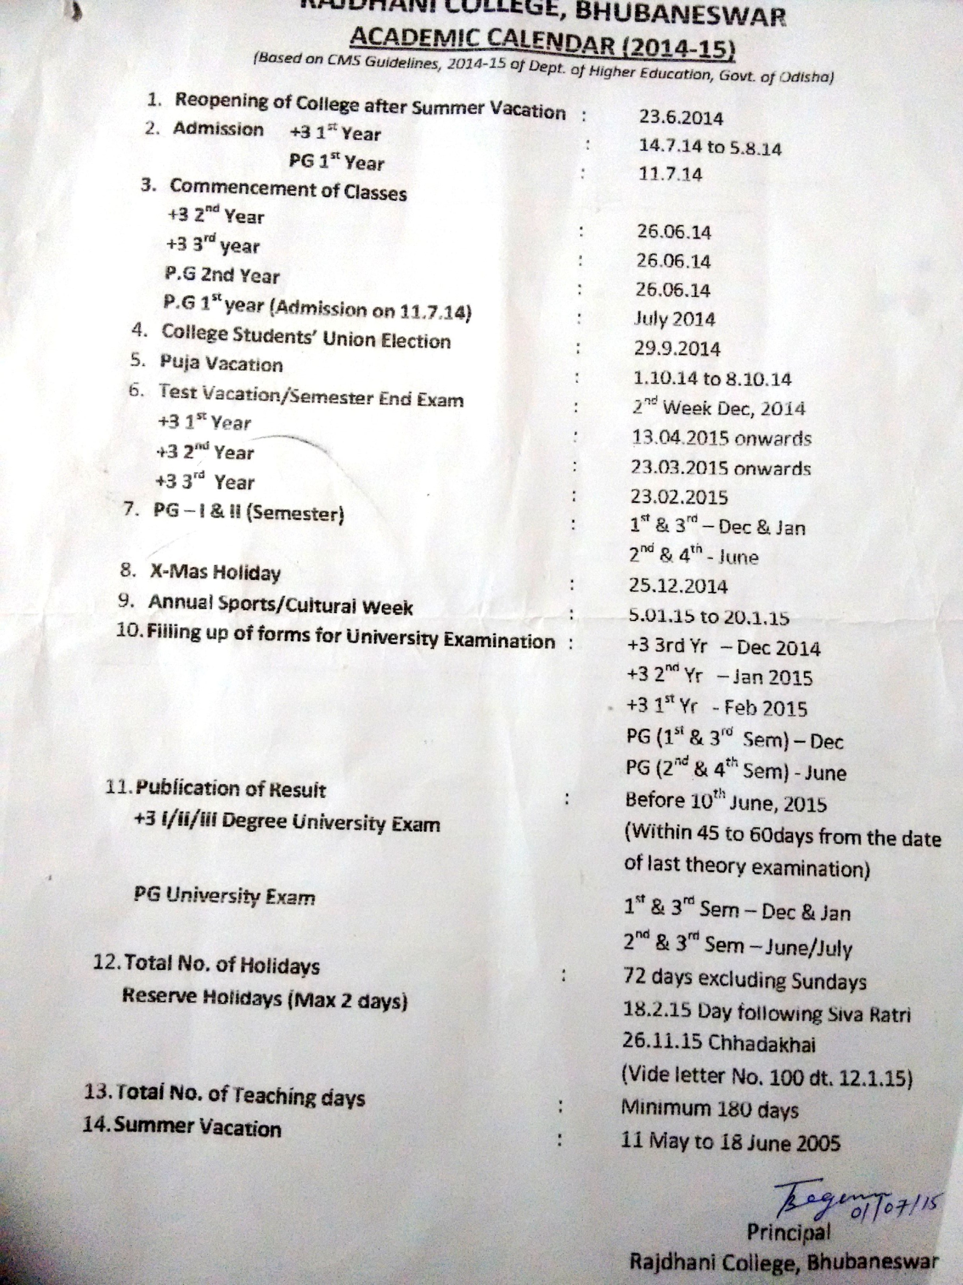

AbbreviationsCAS - Career Advanced Scheme
CAT - Common Admission Test
CBCS - Choice Based Credit System
CE - Centre for Excellence
COP - Career Oriented Programme
CPE - College with Potential for Excellence
DPE - Department with Potential for Excellence
GATE - Graduate Aptitude Test
NET - National Eligibility Test
PEI - Physical Education Institution
SAP - Special Assistance Programme
SF - Self Financing
SLET - State Level Eligibility Test
TEI - Teacher Education Institution
UPE - University with Potential Excellence
UPSC - Union Public Service Commission

***************

